GA-4 SPECIAL POLITICAL AND DECOLONIZATION

STUDY GUIDE

**I. Welcome Letter By Chairs**

Hello dear delegates,

It is with great pleasure that we welcome you on behalf of the SPECPOL Charing team to MPALMUN 2020. It would of course be impolite to continue without introducing ourselves so we will get right to it. Your president chair Şükriye Torun studies ELT and your co-chair Bengisu Berre Özgül studies ELT too. We graduated from Onur Ateş Anatolian High School and that’s why we wanted to take place in MPALMUN again. It is our second experience as chair in SPECPOL committee.

To make your MPALMUN experience unforgettable, we will always be here for you. If you have any questions or concerns before the conference, please do not hesitate to contact any of us. In the meantime, we look forward to meeting you at the beginning of the April, and trust that we will all work together extremely well and most importantly have plenty of fun while doing so!

Many Thanks

[**II**](https://en.wikipedia.org/wiki/World_War_II)**. Introduction to the Committee**

The Fourth Committee of the UN General Assembly, referred to hereafter as the Special Political and Decolonization Committee or SPECPOL for short, has a somewhat more fragmented mandate than other committees of the General Assembly, such as DISEC, ECOFIN, or SOCHUM. The UN itself describes the committee as concerning itself “with a variety of subjects which include those related to decolonization, Palestinian refugees and human rights, peacekeeping, mine action, outer space, public information, atomic radiation and [the] University for Peace [sic]”. In short, SPECPOL covers both the issue of decolonisation, as suggested by its full name, as well as any other political issues not directly dealt with by the mandates of any other UN General Assembly committee.

It should also be noted that, as this is a General Assembly committee, all resolutions are nonbinding. What this means is that operative clause language which is more indicative of a Security Council resolution (e.g. ‘Demands’) should not be used, with non-binding language (e.g. ‘Urges’, ‘Recommends’) being used instead. This also means that any peacekeeping operations or punitive measures (such as economic sanctions) cannot directly be authorised by this committee, although it is within the committee’s power to suggest or recommend that the Security Council take these actions in a manner stipulated by the committee. It is still acceptable, however, to refer to resolutions passed previously by non-General Assembly committees (including the Security Council) in the perambulatory clauses of a resolution.

[**II**](https://en.wikipedia.org/wiki/World_War_II)**I. PREVENTION OF WAR CRIMES**

**1. Introduction to the Topic:** A war crime is an act that constitutes a serious violation of the [laws of war](https://en.wikipedia.org/wiki/Laws_of_war) that gives rise to individual criminal responsibility. Examples of war crimes include [intentionally killing civilians](https://en.wikipedia.org/wiki/Crimes_against_humanity) or [prisoners](https://en.wikipedia.org/wiki/Prisoners_of_war), [torturing](https://en.wikipedia.org/wiki/Torturing), destroying civilian property, taking [hostages](https://en.wikipedia.org/wiki/Hostage), performing a [perfidy](https://en.wikipedia.org/wiki/Perfidy), [raping](https://en.wikipedia.org/wiki/Wartime_sexual_violence), [using child soldiers](https://en.wikipedia.org/wiki/Children_in_the_military), [pillaging](https://en.wikipedia.org/wiki/Pillaging), declaring that [no quarter](https://en.wikipedia.org/wiki/No_quarter) will be given, and seriously violating the principles of [distinction](https://en.wikipedia.org/wiki/Distinction_(law)) and [proportionality](https://en.wikipedia.org/wiki/Proportionality_(law)), and [military necessity](https://en.wikipedia.org/wiki/Military_necessity).

The concept of war crimes emerged at the turn of the twentieth century when the body of [customary international law](https://en.wikipedia.org/wiki/Customary_international_law) applicable to warfare between [sovereign states](https://en.wikipedia.org/wiki/Sovereign_state) was codified. Such codification occurred at the national level, such as with the publication of the [Lieber Code](https://en.wikipedia.org/wiki/Lieber_Code) in the United States, and at the international level with the adoption of the treaties during the [Hague Conventions of 1899 and 1907](https://en.wikipedia.org/wiki/Hague_Conventions_of_1899_and_1907). Moreover, trials in national courts during this period further helped clarify the law. Following the end of [World War II](https://en.wikipedia.org/wiki/World_War_II), major developments in the law occurred. Numerous trials of [Axis](https://en.wikipedia.org/wiki/Axis_powers) war criminals established the [Nuremberg principles](https://en.wikipedia.org/wiki/Nuremberg_principles), such as notion that war crimes constituted [crimes defined by international law](https://en.wikipedia.org/wiki/International_criminal_law). Additionally, the [Geneva Conventions](https://en.wikipedia.org/wiki/Geneva_Conventions) in 1949 defined new war crimes and established that states could exercise [universal jurisdiction](https://en.wikipedia.org/wiki/Universal_jurisdiction) over such crimes. In the late 20th century and early 21st century, following the creation of several [international courts](https://en.wikipedia.org/wiki/International_court), additional categories of war crimes applicable to armed conflicts other than those between states, such as [civil wars](https://en.wikipedia.org/wiki/Civil_war), were defined.

**2. HISTORY OF THE TOPIC**

**The Hague Conventions** were international treaties negotiated at the First and Second Peace Conferences at [The Hague](https://en.wikipedia.org/wiki/The_Hague), Netherlands, in 1899 and 1907, respectively, and were, along with the Geneva Conventions, among the first formal statements of the [laws of war](https://en.wikipedia.org/wiki/Laws_of_war) and war crimes in the nascent body of secular [international law](https://en.wikipedia.org/wiki/International_law).

**The Geneva Conventions** comprise four [treaties](https://en.wikipedia.org/wiki/Treaty), and three additional [protocols](https://en.wikipedia.org/wiki/Protocol_(diplomacy)), that establish the standards of [international law](https://en.wikipedia.org/wiki/International_law) for humanitarian treatment in war. The singular term *Geneva Convention* usually denotes the agreements of 1949, negotiated in the aftermath of the [Second World War](https://en.wikipedia.org/wiki/Second_World_War) (1939–1945). The Geneva Conventions extensively defined the basic rights of wartime prisoners (civilians and [military personnel](https://en.wikipedia.org/wiki/Military_personnel)), established protections for the wounded and sick, and established protections for the civilians in and around a war-zone. The treaties of 1949 were ratified, in whole or with [reservations](https://en.wikipedia.org/wiki/Reservation_(law)), [by 196 countries](https://en.wikipedia.org/wiki/List_of_parties_to_the_Geneva_Conventions), namely the United States, Israel, India, Pakistan, Iraq, Iran, and others.

**Leipzig war crime trial**  small number of German military personnel of the [First World War](https://en.wikipedia.org/wiki/First_World_War) were tried in 1921 by the German Supreme Court for alleged war crimes.

### International Military Tribunal for the Far East 1946, Also known as the Tokyo Trial, the Tokyo War Crimes Tribunal or simply as the Tribunal, it was convened on May 3, 1946 to try the leaders of the Empire of Japan for three types of crimes: "Class A" (crimes against peace), "Class B" (war crimes), and "Class C" (crimes against humanity), committed during [World War II](https://en.wikipedia.org/wiki/World_War_II).

### Saudi Arabian-led Military Intervention in Yemen, The Saudi Arabian-led military intervention in Yemen has been dubbed as the world’s worst humanitarian crisis by the [United Nations](https://en.wikipedia.org/wiki/United_Nations). The war of more than four years has led [Yemen](https://en.wikipedia.org/wiki/Yemen) to the brink of extinction with millions of civilians facing [famine](https://en.wikipedia.org/wiki/Famine) and starvation at the hands of multiple warring parties; [Houthi rebels](https://en.wikipedia.org/wiki/Houthi_movement), [Saudi Arabia](https://en.wikipedia.org/wiki/Saudi_Arabia), and the [United Arab Emirates](https://en.wikipedia.org/wiki/United_Arab_Emirates). A December 2019 report by the [Amnesty International](https://en.wikipedia.org/wiki/Amnesty_International) followed six months of research and documented the lack of medical attention and neglect faced by more than 4.5 million Yemenis, disabled in the war.

### International Criminal Court 2002 The Rome Statute took effect in 2002, upon ratification by 60 States. In addition to founding the Court and defining the crimes of genocide, war crimes, crimes against humanity, and – as of amendments made in 2010 – the crime of aggression, the Rome Statute also sets new standards for victims' representation in the Courtroom, and ensures fair trials and the rights of the defence. Several nations, most notably the United States, China, Russia, and Israel, have criticized the court. The United States still participates as an observer.

**Some Important Examples of War Crimes in History**

|  |  |  |
| --- | --- | --- |
| **Armed Conflict** | | **Perpetrator** |
| **Incident** | **Type of Crime** | **Notes** |
| **World War l** | | **German Empire** |
| Rape of Belgium | War Crime | In defiance of the [1907 Hague Convention on Land Warfare](https://en.wikipedia.org/wiki/Hague_Convention_of_1907), the German occupiers engaged in mass atrocities against the civilian population of Belgium and looting and destruction of civilian property, |
| World War l | | All major belligerents |
| Employment of [poison gas](https://en.wikipedia.org/wiki/Poison_gas) | Use of poisons as weapons | Poison gas was introduced by Imperial Germany, and was subsequently used by all major belligerents in the war, |
| **World War l** | | **Ottoman Empire** |
| Greek Murder | War Crime | Violent Ethnic Cleansing campaign against Greeks in Anatolia resulting in the deaths of hundreds of thousands. Turkey does not call the event genocide. |
| **World War l** | | **United Kingdom** |
| [Baralong Incidents](https://en.wikipedia.org/wiki/Baralong_Incidents) | War crimes | On 19 August 1915, a German submarine was sunk by the British [Q-ship](https://en.wikipedia.org/wiki/Q-ship). Afterwards, Lieutenant [Godfrey Herbert](https://en.wikipedia.org/wiki/Godfrey_Herbert) ordered his *Baralong* crew to kill the survivors of the German submarine.  Another attack occurred on 24 September, *Baralong* destroyed [U-41](https://en.wikipedia.org/wiki/SM_U-41_(Germany)). |
| **World War l** | | **Russian Empire** |
| The Turkish | War Crime | Analyst of political killings [Rudolph Rummel](https://en.wikipedia.org/wiki/Rudolph_Rummel) compiled sources indicting the forces loyal to the Russian empire for killing hundreds of thousands of Turkish and Kurdish civilians |
| **World War ll** | | **German Empire** |
| The Polish | War Crime | German forces in their military actions engaged in executions of Polish POWs, bombing hospitals, murdering civilians, shooting refugees, and executing wounded soldiers. |
| French and British soldiers | War Crime | In May 1940, British and French soldiers were captured by the SS and subsequently murdered |

**ELEMENTS OF THE WAR CRIME**

War crimes are those violations of international humanitarian law (treaty or customary law) that incur individual criminal responsibility under international law. As a result, and in contrast to the crimes of genocide and crimes against humanity, war crimes must always take place in the context of an armed conflict, either international or non-international.

What constitutes a war crime may differ, depending on whether an armed conflict is international or non-international. For example, [Rome Statute](https://www.icc-cpi.int/resource-library/Documents/RS-Eng.pdf) categorises war crimes as follows:

* Grave breaches of the 1949 Geneva Conventions, related to international armed conflict;
* Other serious violations of the laws and customs applicable in international armed conflict;
* Serious violations common to the four 1949 Geneva Conventions, related to armed conflict not of an international character;
* Other serious violations of the laws and customs applicable in armed conflict not of an international character.

From a more substantive perspective, war crimes could be divided into:

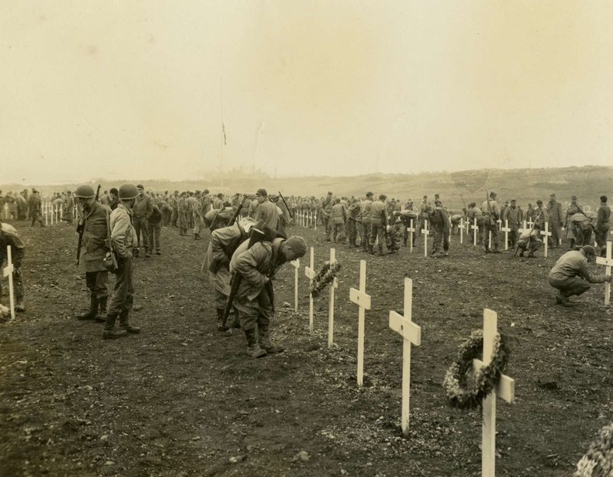a) war crimes against persons requiring particular protection;

b) war crimes against those providing humanitarian assistance and peacekeeping operations;

c) war crimes against property and other rights;

d) prohibited methods of warfare; and

e) prohibited means of warfare.

Some examples of prohibited acts include: murder; mutilation, cruel treatment and torture; taking of hostages; intentionally directing attacks against the civilian population; intentionally directing attacks against buildings dedicated to religion, education, art, science or charitable purposes, historical monuments or hospitals; pillaging; rape, sexual slavery, forced pregnancy or any other form of sexual violence; conscripting or enlisting children under the age of 15 years into armed forces or groups or using them to participate actively in hostilities.

War crimes contain two main elements:

1. A *contextual element*: “the conduct took place in the context of and was associated with an international/non-international armed conflict”;
2. A *mental element*: intent and knowledge both with regards to the individual act and the contextual element.

In contrast to genocide and crimes against humanity, war crimes can be committed against a diversity of victims, either combatants or non-combatants, depending on the type of crime. In international armed conflicts, victims include wounded and sick members of armed forces in the field and at sea, prisoners of war and civilian persons. In the case of non-international armed conflicts, protection is afforded to persons taking no active part in the hostilities, including members of armed forces who have laid down their arms and those placed ‘hors de combat’ by sickness, wounds, detention, or any other cause. In both types of conflicts protection is also afforded to medical and religious personnel, humanitarian workers and civil defence staff.

**PREVENTION OF WAR CRIMES**

War crimes have an important place in International Humanitarian Law, and in this place international courts such as Nuremberg International Military Court have been held. The International Criminal Court for the Former Yugoslavia created by the UN Security Council and the International Criminal Court for Rwanda are examples of recent history.

International Criminal Court was established in Hague to discuss war crime cases committed after July 1 2002. Some countries, especially The US, China and Israel have criticized the court and refused to participate and did not allowed the court to have jurisdiction over their citizens.

War crimes have been punished by national courts since middle ages. The first collection of war crimes as a comprehensive law was carried out in the Lieber Rules issued by President Lincoln in 1863 during the American Civil War. Since then, many international humanitarian law agreements have been prepared, including the La Haye Convention IV, from 1907 and its regulations, the Geneva Conventions 1949 and their protocols from 1977. Article 8 of the International Criminal Court Rome Statute authorizes the International Criminal Court on a large proportion of the war crimes committed during international armed conflict defined in these agreements and international customary law. It confirms the latest developments in international law by giving the International Criminal Court the power to try war crimes committed in non-international armed conflicts, which are the most widespread conflicts of today, such as civil wars

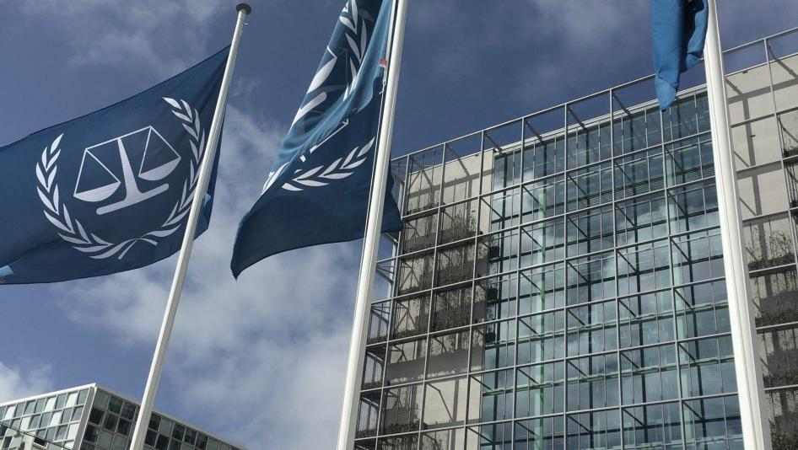

* 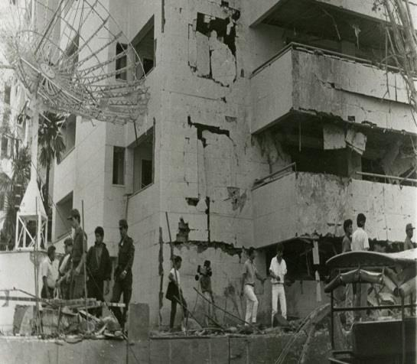Attacks known directly to the civilian population, civilian belongings, humanitarian aid or peace-saving missions, as well as the concrete and direct military advantage that is predicted to provide, will also harm civilian targets or injure civilians or cause casual casualties. prohibited attacks on civilians, including; Attacks against buildings, materials, medical units, means of transportation and people bearing the Red Cross and Red Crescent emblems; and attacks on buildings, historical monuments and hospitals used for religious, educational, artistic, scientific or charitable purposes that are not military targets;
* Killing or injuring surrendered soldiers; physically crippling the limb; carrying out medical or scientific experiments that are not medically legitimate and are not carried out in the interests of the person, which will cause death or seriously endanger the health of the person; attack on one's dignity, in particular degrading and degrading treatment; harming vulnerable people such as rape and other forms of sexual violence and using people as shields;
* 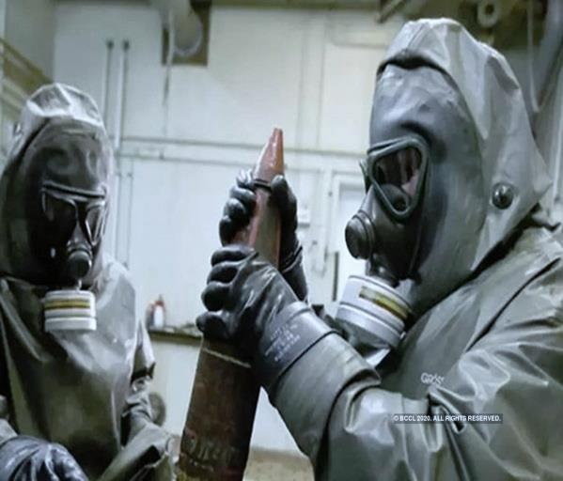Abuse of the truce flag, UN or enemy sign, or Red Cross and Red Crescent emblems; declaring that no prisoners will be taken; looting, destroying or capturing enemy property, unless they justify it with military requirements; using prohibited weapons, such as poison or poisonous weapons, certain gases, bullets that break down in the body, and other weapons to be added to the statute with a change to be made; Some forbidden methods of warfare, such as deliberately starving civilians as a method of war or taking children under the age of 15 to the national armed forces or actively using them in armed conflict;
* Indirect or direct transfer of their civilian populations to the lands occupied by the occupiers, or deportation or transfer of all or part of the population of the occupied lands; Some prohibited actions on occupied territory or against enemy citizens, including removing or suspending the legal rights of enemy citizens or forcing them to participate in military operations against their own country.

Some of the head of government who have been judged because of war crimes:

* [Karl Dönitz](https://tr.wikipedia.org/wiki/Karl_D%C3%B6nitz) (Germany)
* [Hideki Tojo](https://tr.wikipedia.org/wiki/Hideki_Tojo) (Japan)
* [Charles Taylor](https://tr.wikipedia.org/w/index.php?title=Charles_Taylor&action=edit&redlink=1) (Liberia, died in the litigation process.)
* [Saddam Hüseyin](https://tr.wikipedia.org/wiki/Saddam_H%C3%BCseyin) (Iraq, he was was executed.)

**Bibliography and further Readings:**

<https://www.icc-cpi.int/about>

<https://www.un.org/en/genocideprevention/war-crimes.shtml>

<https://en.wikipedia.org/wiki/List_of_war_crimes>

<https://en.wikipedia.org/wiki/War_crime>

<https://tr.wikipedia.org/wiki/Sava%C5%9F_su%C3%A7u>